Progress Note

Date: March 12th, 2018 Start Time: 15:55 End Time: 16:05

Type of Contact: In-person Members Present: Randy, Elizabeth, Matthew and Faith

Assessment Results: Treating Plan

Summary: The purpose of today’s interview was to know the progress of the treatment of last time and developed more committed, measurable treatment goals. The first plan for the Walker family is “family Movie night”. It didn’t work well because Elizabeth and Randy have disagreement on which movie they should choose to watch. The problem was solved by allowing kids to pick up the movies. Obviously, couples had different expectation on the family movie night. Elizabeth felt upset about Randy just be there physically; however, Randy didn’t really understand what Elizabeth need. Randy brought out moving the movie night to Sunday which again aroused Elizabeth’s anger. Elizabeth’s complaint included the trust issue because she had no ideas about what Randy was doing outside. Following the last treatment, I brought up their communication problem. I noticed that their communication involved with the negative emotion and languages, which became the force drove Randy away his family. Elizabeth reported she felt like a single mother and emphasized on there was no support around her. I assume Elizabeth’s problems need the cognitive intervention account for the negative thoughts she had. One agreement on Faith after-school program was written down in today’s session. Randy agreed to bring Faith to school for several times a week, Faith was more enjoyed when she could take some snacks. However, both Faith and Matthew reported the rare caring and attention from both parents. I concerned about the drawing from Matthew in this session because the painting was about “a woman holding a knife”(Please see Appendix E for Mathew’s painting) As Matthew explained the “knife” symbolized the anger of his mother, I assume Elizabeth’s negative emotion had great influence her children. Briefly, this session ended up with two written goals (Please see the Appendix F for treatment plan) and the problems of communication, parenting and different expectation need further evaluations.

Plan: Tracking the progress of the treatment plan, discussion for extra possible solutions, continue applying assessment.

Signature_______________________________________________________________________

Appendix D

Matthew’s drawing

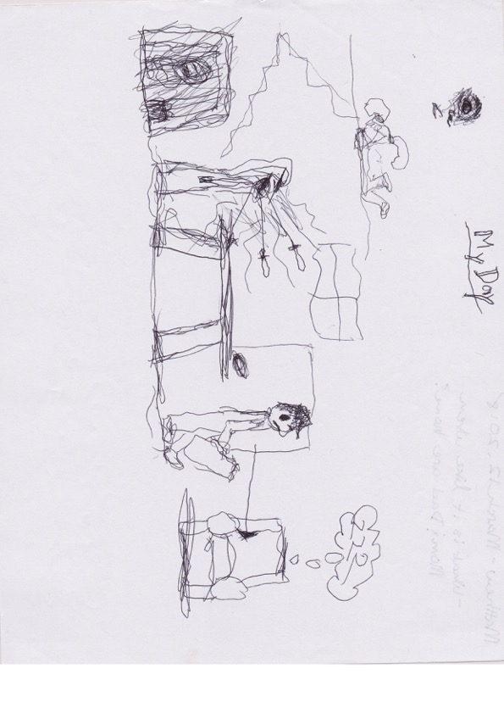

Faith’s drawing

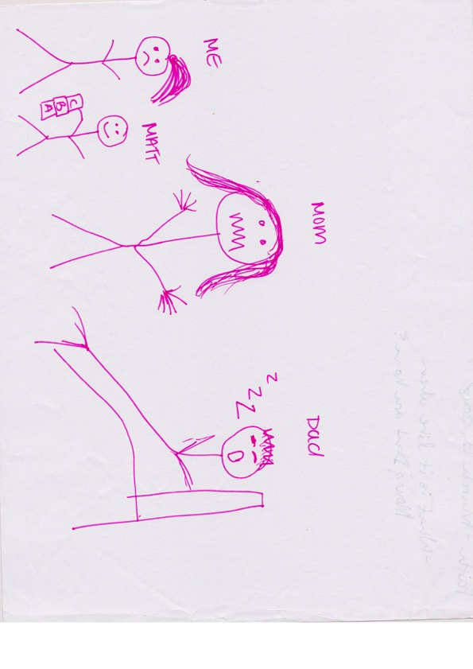

Appendix F

Treatment Plan

